Chapter 3, Problem 6.

Solve for V₁, in Fig. 3.55, using nodal analysis.

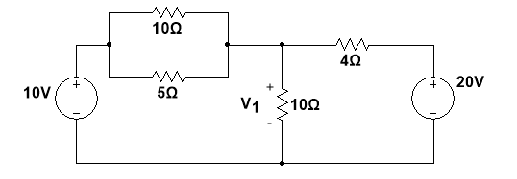

Figure 3.55
For Prob. 3.6.

